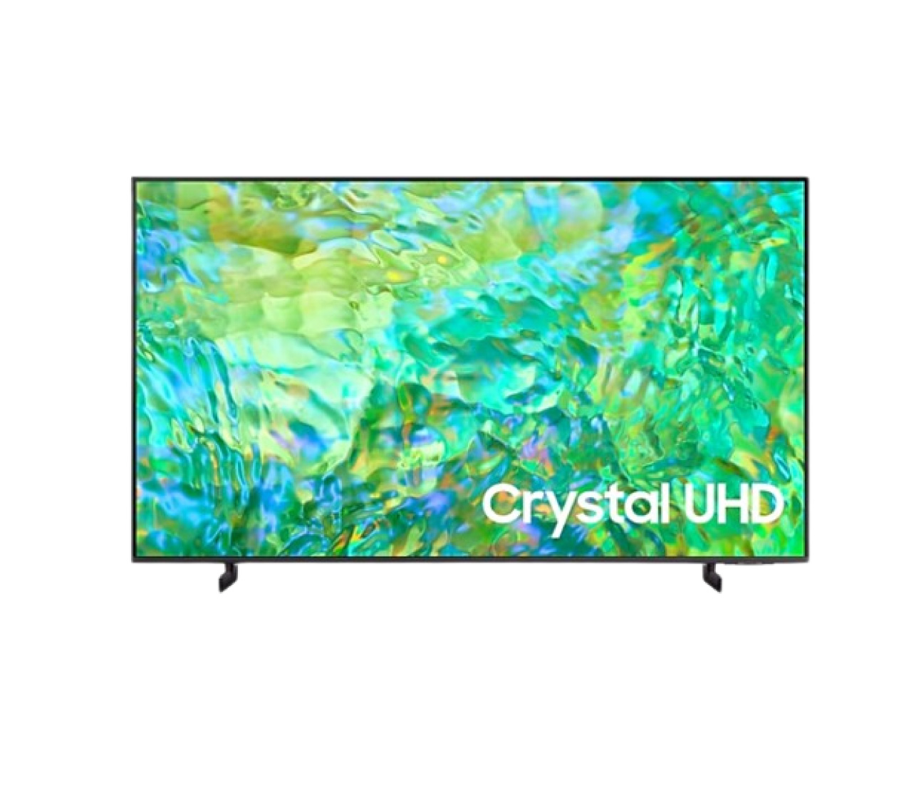

**Picture Quality**

**Contrast Enhancer**

**Enhanced sense of depth and color**

Contrast Enhancer dynamically adjusts the contrast, resulting in an enhanced sense of depth and color.

**HDR**

**SDR**

**HDR (High Dynamic Range)**

**See the details in every scene**

High Dynamic Range shows an enormous spectrum of colors and light levels, so you can enjoy all the visual details in every scene.

Next

ftd16_interactive multi feature-product detail-indicatorftd16_interactive multi feature-product detail-indicator

**Gaming Experience**

**Motion Xcelerator**

**Smooth motion for a clear picture**

Experience clear picture and performance. Motion Xcelerator automatically estimates and compensates frames for the source of contents.

Auto Low Latency Mode (ALLM)

**Auto Low Latency Mode (ALLM)**

**Instantly reacts to your commands**

Experience smooth gaming without motion blur and judder. ALLM optimizes your screen, so you have more control with barely noticeable input lag.

Next

ftd16_interactive multi feature-product detail-indicatorftd16_interactive multi feature-product detail-indicator

**Sound**

A person on a motorcycle is zipping past from one side to another. Built-in speakers follow the sound of the motorcycle as it moves.

**Object Tracking Sound Lite (OTS Lite)**

**Virtual sound that tracks the action**

A 3D surround sound with our virtual top channel audio will allow you to be fully immersed in the audio experience.

Only sound from the Soundbar was activated when Q-Symphony was off, but sound from both the TV and Soundbar turned on when Q-Symphony turned on.

**Q-Symphony**

**TV and soundbar orchestrated in perfect harmony**

Q-Symphony uniquely allows TV and soundbar speakers to operate simultaneously without muting TV speakers for a more harmonious sound.

* Check for Q-Symphony compatibility on soundbar product specifications.  
* Soundbar sold separately.

**Adaptive Sound**

**Sound fine-tuned to your content**

Adaptive sound has audio scenic intelligence that optimizes sound based on real time scene analysis by content type.

Next

ftd16_interactive multi feature-product detail-indicatorftd16_interactive multi feature-product detail-indicatorftd16_interactive multi feature-product detail-indicator

**Design**

A TV is placed on top of an adjustable stand.

**Adjustable Stand_Flat**

**Height that fits your space**

Adjust the height of your TV stand when you want without space constraint. It is also just the right stand to perfectly fit your soundbar.

A TV is placed on top of an adjustable stand.

**Adjustable Stand_Float**

**Height that fits your space**

Adjust the height of your TV stand when you want without space constraint. It is also just the right stand to perfectly fit your soundbar.

Next

ftd16_interactive multi feature-product detail-indicatorftd16_interactive multi feature-product detail-indicator

**Smart Feature**

**SmartThings**

**Your best home butler**

Relax and let SmartThings seamlessly connect to, monitor and control all your smart devices to intuitively control your home via a built-in hub.

* Available technology, functions and features may vary by country, service provider, network environment or product, and are subject to change without notice.  
* Requires a Wi-Fi, Bluetooth or other wireless network connection and login to Samsung account.  
* Connected devices are sold separately.  
* Use of calm technology requires agreement from both SmartThings privacy notice and auto registered device.  
* UI is subject to change without prior notice.

**Why Samsung TV**

AI Energy Mode

**AI Energy Mode**

**Energy savings with AI Energy mode and SmartThings**

With AI Energy Mode, you can conserve power and track your savings. Surrounding light levels are automatically detected and analyzed to adjust the brightness, reducing overall power consumption.

* AI Energy Mode is exclusive to 2023 new models of CU7000↑ and 32" LS03C. The actual power reduction may vary by model and is based on internal testing. It is supported only in certain regions. The SmartThings app is required to utilize AI Energy Mode. Please note that AI Energy Mode does not support Game, Intelligent, Art, Screen Mirroring, Ambient or Retail Mode. For NA, LATAM, KR, SE Asia, SW Asia: In environments where the surrounding light exceeds 120 lux, certain aspects of the AI energy-saving feature may not function, resulting in reduced energy savings. For EU, CIS, Africa: In environments where the surrounding light exceeds 80 lux, certain aspects of the AI energy-saving feature may not function, resulting in reduced energy savings. Energy saving rate may vary according to regions, models, sizes, viewing conditions or types of content.

**Samsung Knox**

**Your privacy. Secured. On Samsung TVs**

Feel at ease with a multi-layered security solution shielding your data, such as pin codes and passwords. Even Home IoT devices connected to your TV are secured. Regular updates further fortify your TV, protecting it from harmful attacks.

* UI is subject to change without prior notice.  
* Samsung Knox applies to Samsung TVs powered by Tizen®, launched since 2015.  
* Security software update is guaranteed for at least three years from TV product launch.  
* Latest TV software update is required.

**SolarCell Remote**

**Remote controller charged with sunlight and indoor lighting**

With a solar panel on its back that you can use for charging, now you don’t need to use disposable batteries as they are not the best for the environment.

* To charge the remote with solar energy, set the TV remote down with the solar panel facing up.  
* Place it in your living room while your lights are turned on, or you can place it near a window where it will soak in natural sunlight.  
* If SolarCell Remote’s battery is drained, it would need to be charged with a USB-C cable.  
* The battery level of SolarCell Remote can be checked through the pop up guide on TV screen.  
* The design and button layout of the SolarCell remote may vary by regions.

**Triple Protection**

**Stay worry-free with Triple Protection on Samsung TVs**

With Triple Protection, your TVs are protected against humidity, surge and lightning. This adds to the long life and durability of the TVs.

* Our triple protection feature offers enhanced protection against power surge, humidity and lightning. However, please note that although the mentioned features reduces the risk, they may not completely eliminate damage in extreme circumstances

Next

ftd16_interactive multi feature-product detail-indicatorftd16_interactive multi feature-product detail-indicatorftd16_interactive multi feature-product detail-indicatorftd16_interactive multi feature-product detail-indicator

**Specifications**

* Resolution**3,840 x 2,160**

* undefined**8**

* HDMI**3**

* USB**2**